**Name: Mudit Mohit**

**Enrolment No.: BT21GCS057**

**Batch: 2021**

**Section: C3**

**Assignment 3**

**Git**

Q1.) (a) Create an account on Git Hub.

Ans.

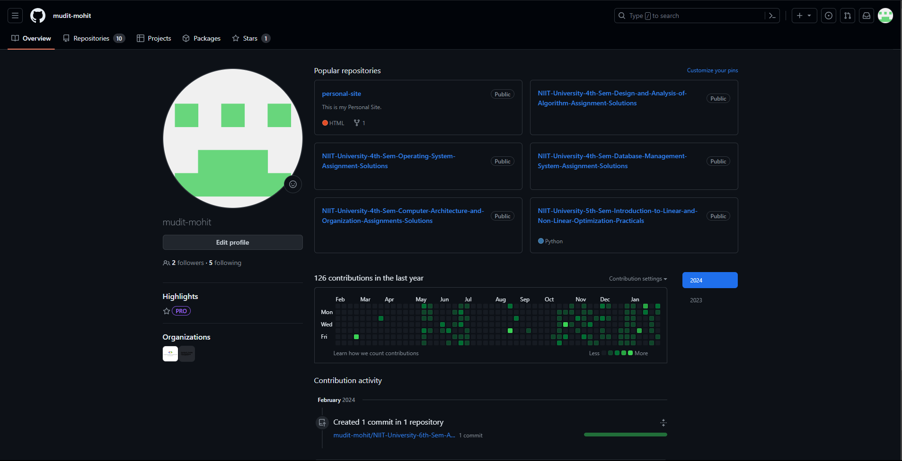

b.) You will download load and install git software.

Ans.

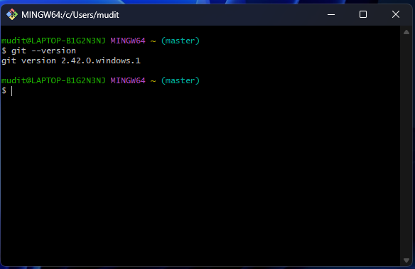

c.) You’ll create a new repository.

Ans.)

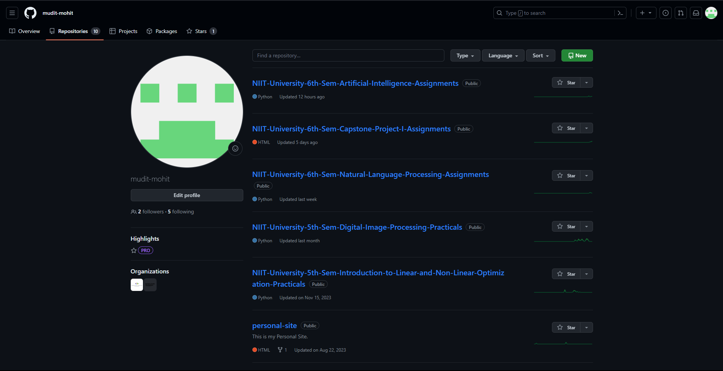

d.) You’ll execute initial commands on the new repository page.

Ans. git init

git remote add origin git@github.com: your-username/my-project.git

git add README.md LICENSE. gitignore

git commit -m "Initial commit"

git push origin main

Q2.) Send and accept a collaboration invite and then do a clone, push, and pull between your Capstone Project team members.

Ans.

